

**Asset Practice Questions: Mathematics**

1. Shown below are two bundles with 16 sticks in each.

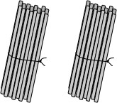

If you untie the sticks and put them in bundles of 8 each, how many bundles will you get?

A. 2

B. 4

C. 8

D. 16

2. A number is multiplied by 1. The answer will always be

A. 0.

B. 1.

C. the number itself.

D. 1 more than the number.

3. Javed is playing a computer game where he has to make his frog move from the ''Start'' flag to the

''Finish'' flag by jumping on the tiles in between. He gains 100 points for jumping on a white tile and

loses 50 points for jumping on a grey tile. On reaching the ''Finish'' flag, he gains 100 extra points.

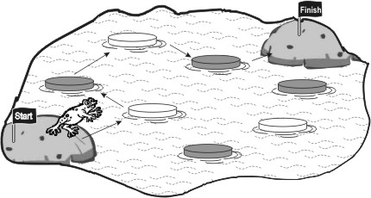

If the frog takes the path as shown in the picture, how many points will he score?

A. 0

B. 100

C. 200

D. 300

4. Bob is playing a board and dice game called 'Car Race' with his friend. A part of the board is shown below:

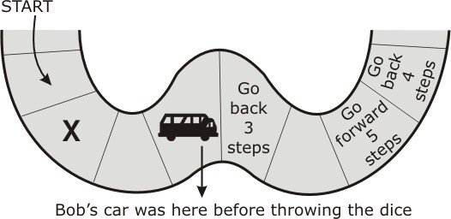

Bob's car is shown on the board. After throwing the dice, his car had to move to the place marked 'X'. What number did he throw on the dice?

A. 1

B. 2

C. 3

D. 4

5. A classroom has a wall chart listing numbers from 1 to 100. A PART of it is shown below.

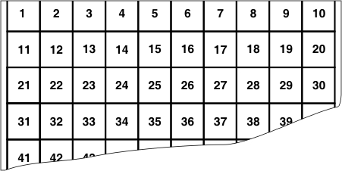

On this chart, the numbers 11, 21, 51 and 91 can be connected by a straight line. Which of the following set of numbers can also be connected by a single straight line on this chart?

A. 2, 4, 24, 42

B. 5, 10, 15, 20

C. 23, 24, 33, 34

D. 25, 34, 43, 52

6. For a festival in Kanthi's house, a chain of bulbs is hung in her puja room. The bulbs in the chain are arranged in a pattern as shown below.

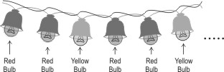

How many red bulbs will be there in the chain if there are 12 bulbs altogether?

A. 2

B. 4

C. 8

D. 12

7. 25 children are standing in a line to play a game. They are given numbers 1 to 25 to identify themselves. Then, every 4 thchild in the line is asked to come a little forward.

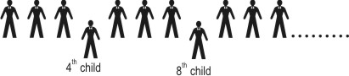

One of the children who came forward could be the child.

A. 2 nd child

B. 10 th child

C. 24 th child

D. 25 th child

8. These shapes are arranged in a pattern.



Which number series follows the same pattern as the shapes?

A. 12122122212222

B. 12121212121212

C. 12112211122211

D. 11221122112211

9. Students from classes 4-A, 4-B and 4-C will take part in a group dance.So we need to select an equal number of girls from each class, to have 21 girls in the dance. In the same way we need to select an equal number of boys from each class, to have 15 boys in the dance. How many students do we need to select from each class?

A. 5

B. 7

C. 12

D. 36

10. The two number sequences below follow the same pattern. 2, 4, 8, 16......and so on 3, 6, 12, 24....and so on Which sequence below follows the same pattern as the two number sequences above?

A. 2, 4, 6, 8....and so on

B. 3, 6, 9, 12....and so on

C. 5, 10, 15, 20.....and so on

D. 10, 20, 40, 80.....and so on

11. Some juice is poured into 3 jars as shown here.





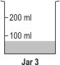

Which of the following is true?

A. Jar 3 has the most amount of juice.

B. Jar 2 has the most amount of juice.

C. Jar 1 has the most amount of juice.

D. Jars 2 and 3 have equal amount of juice.

12. The same ball is used to check the weight of an apple and a mango.

Here is how the balance looks for the apple and the mango.

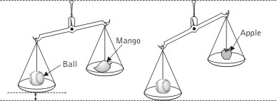

What can be said about the weight of the mango from the figure? (Hint: Look how far down, the pan with the ball has gone.)

A. It is same as that of the apple.

B. It is less than that of the apple.

C. It is greater than that of the ball.

D. It is greater than that of the apple.